ROB’S TO DO LIST
API - as per Scottie
SMS Keyword on registration pages - Subscribe (SBO, BETOWI, PBJ
Update existing phone numbers to SMS keyword on SBO
Auto-update on last login, real balance, deposit Y/N (updater fields) (SBO, BETOWI, PBJ)
Clean Database (SBO) for real SBO only
PBJ - Can we direct non-north American to separate list

AFFILIATE PLATFORM
ODDS WIDGETS - make scroll arrow more visible (color and bold) betting odds column should click back to sportsbook section
LIVE ODDS PAGE – create widget for SBO / BETOWI. Integrate UFC lines, lines should click back to sportsbook section, tags for SEO
MARKETING TOOLS – separate casino tools from Sportsbook tools (SBO, WW and BETOWI)
VIDEOS – add to VRB with tracking link (all brands)
MARKETING REPORT –
- in “web” field have an option for “ALL” websites integrated into 1 report
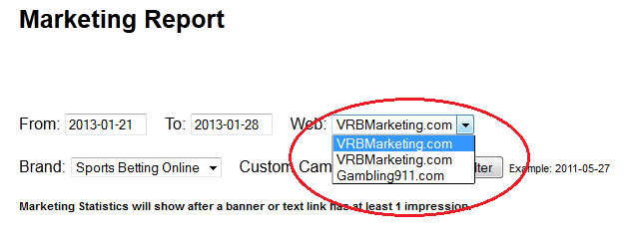
- edit PROMO & CAMPAIGN columns in report to show what kind of tool was used. Ie. Text link. Same should apply to new PID search tool.

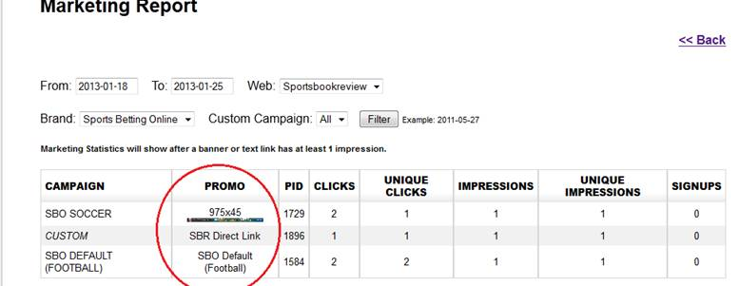
SWAP OUT LINKS – tracking links should carry the site / brand URL
SEO TAGS – integrate SEO friendly tags, links to all tools
SEARCH PIDS – database search of PIDS

CRM & REPORTS
DISABLE – disable from the call back queue any players that have made their “first deposit”.
INTERNAL JOIN FORM – forms should auto populate player info
NEW DISPOSITION – add new disposition called “hand over” into the status drop down menu. This will release the player from the current sales clerk so another clerk has the chance to call them before they get limboed.
SEARCH BY AFs – a drop down menu that allows sales clerk to filter players by AF. Only those attached to him for “call back”. This will help focus conversion for specific AF.
CALL BACK – search by call back date (date range)
CONVERSION REPORT – for sales team.
RELOAD REPORT – pull a daily report of players that have their balance under $10 and no pending wagers. (only attached to affiliates such as AF1, AF2, AF37, AF51, AF55, AF1000+. Sort by reload win and reload lose.
HOLD NEW NAMES - slow down the loading of new sign ups into the calling queue (get new name) by 1 hour.
TIME STAMP – add time stamp to calls and view windows
COMMISSION REPORT – integrated monthly report to help create affiliate statements (balance, new sign ups, new depositing sign ups and total active players)
CALCULATE CUSTOMER REPORT – fix and integrate for all brands

WORD PRESS
NEW BANNER LOAD TOOL - set default, load multiple banners, not load dups
INACTIVE AFFILIATES – hide closed affiliates ( do not erase)
DELETE ALL BANNERS WITH NO TRAFFIC (0 clicks / 0 impressions)

